United States Customary System (USCS)
# Source: AI Source: Provided by: [Data Path: Persons Table -> ID Column: 1, Name_En Column: Motasem Essam] -> From: [ChatGPT] on [7/17/2026]
The United States Customary System (USCS) is a non-metric measurement system used primarily in the United States. It evolved from the traditional English system of measurement that existed before the creation of the British Imperial System in 1824. Although many of its units share the same names as Imperial units, several units—especially those for volume and capacity—have different definitions.
Today, the USCS is widely used in daily life, construction, engineering, manufacturing, transportation, and commerce within the United States, while scientific work generally uses the International System of Units (SI).

Definition
# Source: AI Source: Provided by: [Data Path: Persons Table -> ID Column: 1, Name_En Column: Motasem Essam] -> From: [ChatGPT] on [7/17/2026]
The United States Customary System (USCS) is a standardized system of measurement used primarily in the United States for measuring physical quantities such as length, mass, volume, capacity, temperature, and area.
Unlike the Metric System, the USCS is not decimal-based. Unit conversions use various factors such as 12, 3, 16, 8, 4, 5280, and others.

History
# Source: AI Source: Provided by: [Data Path: Persons Table -> ID Column: 1, Name_En Column: Motasem Essam] -> From: [ChatGPT] on [7/17/2026]
The USCS developed from the English system of measurement used in the American colonies before the British Imperial System was introduced in 1824.
Key milestones:
- Before 1776 – American colonies used English customary units.
- 1824 – Britain adopted the Imperial System, but the United States continued using the earlier English units.
- 1832 – The U.S. government officially recognized customary units for federal use.
- Today – USCS remains the primary measurement system for everyday life in the United States, while SI is used in science and many federal applications.

Characteristics
# Source: AI Source: Provided by: [Data Path: Persons Table -> ID Column: 1, Name_En Column: Motasem Essam] -> From: [ChatGPT] on [7/17/2026]
The USCS is:
- Non-metric.
- Non-decimal.
- Based on traditional English units.
- Standardized within the United States.
- Widely used in everyday activities and industry.

Common Quantities Measured
# Source: AI Source: Provided by: [Data Path: Persons Table -> ID Column: 1, Name_En Column: Motasem Essam] -> From: [ChatGPT] on [7/17/2026]
The USCS includes units for:
- Length
- Distance
- Area
- Volume
- Capacity
- Mass
- Weight
- Temperature
- Speed
- Pressure

Units of Length
# Source: AI Source: Provided by: [Data Path: Persons Table -> ID Column: 1, Name_En Column: Motasem Essam] -> From: [ChatGPT] on [7/17/2026]
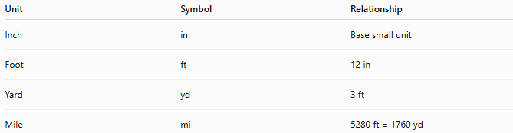
Unit | Symbol | Relationship
Inch | in | Base small unit
Foot | ft | 12 in
Yard | yd | 3 ft
Mile | mi | 5280 ft = 1760 yd

Units of Area
# Source: AI Source: Provided by: [Data Path: Persons Table -> ID Column: 1, Name_En Column: Motasem Essam] -> From: [ChatGPT] on [7/17/2026]
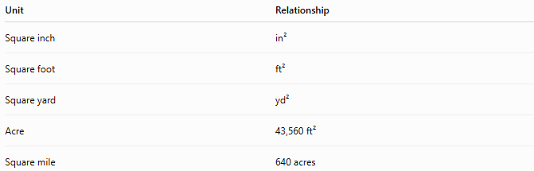
Unit | Relationship
Square inch | in²
Square foot | ft²
Square yard | yd²
Acre | 43,560 ft²
Square mile | 640 acres

Units of Volume
# Source: AI Source: Provided by: [Data Path: Persons Table -> ID Column: 1, Name_En Column: Motasem Essam] -> From: [ChatGPT] on [7/17/2026]
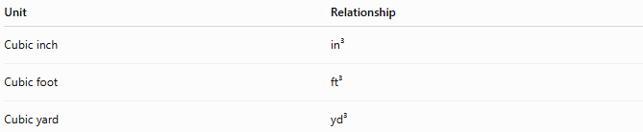
Unit | Relationship
Cubic inch | in³
Cubic foot | ft³
Cubic yard | yd³

Units of Liquid Capacity
# Source: AI Source: Provided by: [Data Path: Persons Table -> ID Column: 1, Name_En Column: Motasem Essam] -> From: [ChatGPT] on [7/17/2026]
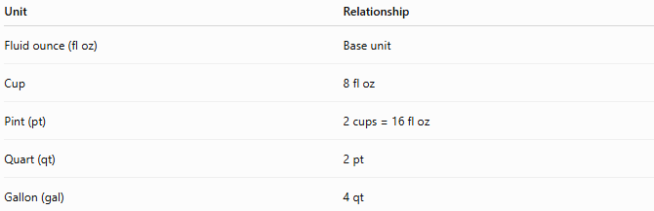
Unit | Relationship
Fluid ounce (fl oz) | Base unit
Cup | 8 fl oz
Pint (pt) | 2 cups = 16 fl oz
Quart (qt) | 2 pt
Gallon (gal) | 4 qt
Note: The U.S. gallon is different from the Imperial gallon.

Units of Dry Capacity
# Source: AI Source: Provided by: [Data Path: Persons Table -> ID Column: 1, Name_En Column: Motasem Essam] -> From: [ChatGPT] on [7/17/2026]
The USCS also includes separate units for measuring dry goods.
Common units include:
- Pint
- Quart
- Peck
- Bushel
These differ from the corresponding liquid measures.

Units of Mass (Weight)
# Source: AI Source: Provided by: [Data Path: Persons Table -> ID Column: 1, Name_En Column: Motasem Essam] -> From: [ChatGPT] on [7/17/2026]
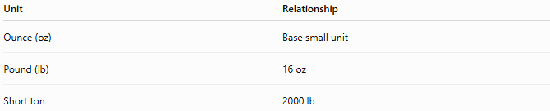
Unit | Relationship
Ounce (oz) | Base small unit
Pound (lb) | 16 oz
Short ton | 2000 lb

Units of Temperature
# Source: AI Source: Provided by: [Data Path: Persons Table -> ID Column: 1, Name_En Column: Motasem Essam] -> From: [ChatGPT] on [7/17/2026]
The USCS commonly uses:
- Degree Fahrenheit (°F)
Water freezes at:
$${32}^{∘}\text{F}$$
Water boils at:
$${212}^{∘}\text{F}$$
under standard atmospheric pressure.

Examples
# Source: AI Source: Provided by: [Data Path: Persons Table -> ID Column: 1, Name_En Column: Motasem Essam] -> From: [ChatGPT] on [7/17/2026]
Example 1
Length
$$6\text{ ft}$$

Example 2
Distance
$$25\text{ mi}$$

Example 3
Weight
$$180\text{ lb}$$

Example 4
Capacity
$$2\text{ gal}$$

Advantages
# Source: AI Source: Provided by: [Data Path: Persons Table -> ID Column: 1, Name_En Column: Motasem Essam] -> From: [ChatGPT] on [7/17/2026]
The USCS:
- Is familiar to most people in the United States.
- Is deeply integrated into American industry and construction.
- Supports compatibility with existing infrastructure.
- Is widely used in manufacturing, engineering, and transportation within the United States.

Disadvantages
# Source: AI Source: Provided by: [Data Path: Persons Table -> ID Column: 1, Name_En Column: Motasem Essam] -> From: [ChatGPT] on [7/17/2026]
The USCS:
- Is not decimal-based.
- Uses multiple conversion factors.
- Is less convenient for scientific calculations.
- Requires frequent conversions when working internationally.
- Differs from the Imperial System despite sharing many unit names.

Applications
# Source: AI Source: Provided by: [Data Path: Persons Table -> ID Column: 1, Name_En Column: Motasem Essam] -> From: [ChatGPT] on [7/17/2026]
The USCS is commonly used in:
- Construction
- Manufacturing
- Transportation
- Road signs
- Real estate
- Retail
- Agriculture
- Household measurements
- Mechanical engineering
- Everyday life in the United States

Everyday Examples
# Source: AI Source: Provided by: [Data Path: Persons Table -> ID Column: 1, Name_En Column: Motasem Essam] -> From: [ChatGPT] on [7/17/2026]
USCS units are used when:
- Measuring a person's height in feet and inches.
- Expressing body weight in pounds.
- Buying gasoline in gallons.
- Cooking with cups, tablespoons, and teaspoons.
- Measuring room dimensions in feet.
- Reading outdoor temperatures in degrees Fahrenheit.
- Expressing road distances in miles.

Common Mistakes
# Source: AI Source: Provided by: [Data Path: Persons Table -> ID Column: 1, Name_En Column: Motasem Essam] -> From: [ChatGPT] on [7/17/2026]
- Assuming the USCS and Imperial systems are identical.
- Using the wrong gallon or fluid ounce.
- Mixing USCS and SI units without proper conversion.
- Assuming the system is decimal-based.

Key Points
# Source: AI Source: Provided by: [Data Path: Persons Table -> ID Column: 1, Name_En Column: Motasem Essam] -> From: [ChatGPT] on [7/17/2026]
- The United States Customary System (USCS) is used primarily in the United States.
- It originated from the English customary system rather than the later British Imperial System.
- It is non-metric and non-decimal.
- Many units share names with Imperial units but have different definitions, especially for liquid measures.
- Scientific work in the United States generally uses the SI system.

United States Customary System vs. SI System
# Source: AI Source: Provided by: [Data Path: Persons Table -> ID Column: 1, Name_En Column: Motasem Essam] -> From: [ChatGPT] on [7/17/2026]
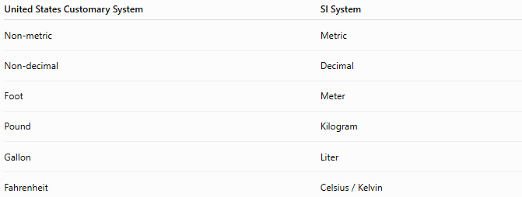
United States Customary System | SI System
Non-metric | Metric
Non-decimal | Decimal
Foot | Meter
Pound | Kilogram
Gallon | Liter
Fahrenheit | Celsius / Kelvin

United States Customary System vs. Imperial System
# Source: AI Source: Provided by: [Data Path: Persons Table -> ID Column: 1, Name_En Column: Motasem Essam] -> From: [ChatGPT] on [7/17/2026]
Although they have many units with the same names, they are different systems.
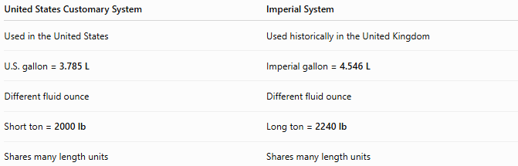
United States Customary System | Imperial System
Used in the United States | Used historically in the United Kingdom
U.S. gallon = 3.785 L | Imperial gallon = 4.546 L
Different fluid ounce | Different fluid ounce
Short ton = 2000 lb | Long ton = 2240 lb
Shares many length units | Shares many length units

United States Customary System vs. Metric System
# Source: AI Source: Provided by: [Data Path: Persons Table -> ID Column: 1, Name_En Column: Motasem Essam] -> From: [ChatGPT] on [7/17/2026]
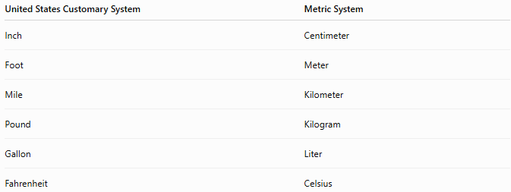
United States Customary System | Metric System
Inch | Centimeter
Foot | Meter
Mile | Kilometer
Pound | Kilogram
Gallon | Liter
Fahrenheit | Celsius

Conclusion
# Source: AI Source: Provided by: [Data Path: Persons Table -> ID Column: 1, Name_En Column: Motasem Essam] -> From: [ChatGPT] on [7/17/2026]
The United States Customary System (USCS) is a non-metric measurement system used primarily in the United States. It evolved from traditional English measurement units and includes familiar units such as the inch, foot, yard, mile, pound, gallon, and degree Fahrenheit. Although it shares many unit names with the British Imperial System, several important units—particularly those for volume and capacity—have different definitions. While the International System of Units (SI) is the standard for science and international communication, the USCS remains the dominant system for everyday life, construction, manufacturing, and commerce within the United States.

